FRICTION STIR WELDING OF ALUMINIUM 6061 ALLOY

# Sharath Chandra H Sa*,Vijeesh Vijayanb, Praveena H Gowdac, Ashvin Ashok Naikd, Nitheshe, Jeethesh Jainf

a Assistant professor, Department of Mechanical Engineering, NMAM Institute of Technology, Nitte 574110, Karnataka, India.

b Associate professor, Department of Mechanical Engineering, NMAM Institute of Technology, Nitte 574110, Karnataka, India.

c,d,e,f UG scholars, Department of Mechanical Engineering, NMAM Institute of Technology, Nitte 574110, Karnataka, India.

**Keywords:** Friction stir welding, Al 6061 alloy, microstructure, mechanical properties

***Abstract*:** *Friction stir welding (FSW) is a solid-state welding technique that involves merge different opposite metal parts with a non-consumable tool without melting any material from the workpiece. Heat is produced by friction between both the revolving tool and the work medium, producing a softer region near the FSW tool. The main purpose of this study was to look at the friction stir welding (FSW) system parameters for 6061 alloys and evaluate the features of the connections that produced. The friction stir welding treatment factor, spindle speed in 1000 rpm, and feed rate in mm/min, all were changed in the investigations (30, 50, 70). The impact of welding parameters on the mechanical properties and microstructure of welds were fully examined Defect-free FSW welding having precise and flawless faces were obtained at the specified welding parameters. The results demonstrate that grain size changes depending on the material and FSW process conditions applied in the connection, and that defect-free and clean surface welds can be accomplished at a feed rate of 70 mm/min.*

## INTRODUCTION:

In the welding field, friction stir welding (FSW) is a comparatively new welding technology. In 1991, the Welding Institute (TWI) of Cambridge, England, was the first one to develop solid-state welding technology. This procedure is simple, ecofriendly, and energy-efficient. Friction Stir Welding is commonly used for the aviation, shipyard, and automotive manufacturers, among many other industries. This is due to a number of advantages over the traditional welding methods, like extremely low distortion, the lack of consumable, and need for minimal specific surface modification. Aluminum are widely used in automotive and aviation applications due to better properties such as high strength, rigidity, interfacial performance, low coefficient of thermal expansion, high thermal conductivity, max tensile ratio, and high corrosion resistant.

Employing traditional fusion welding methods to weld aluminium is a major challenge. Traditional fusion welding procedures are likely to crack, gaps, porosity, as well as other weld problems. It's a cause for concern because the thin oxide film development, good thermal conductivity, and high thermal expansion coefficient. Due to solidification shrinkage, hydrogen as well as other gases have such a high solubility in the molten state.

In FSW, a rotating tool is placed into the joint between the two welded plates. Tool traverse promotes mechanical (solidstate) mixing of the materials on the advancing and receding edges of a weld. In this research, aluminium alloy were friction stir-welded. The influence of tool parameters (rotating speed,

traverse speed) on the mechanical properties and microstructure of FSW weldment were explored in tests.

Murr [et.al,](http://et.al/) A comprehensive variety of precipitation processes associated with a friction-stir-weld in a thin 6061T6 aluminums sheet, including dynamic recrystallization and grain growth patterns, as well as residual microstructures, have been thoroughly investigated.[1]. Tan[g et.al,](http://et.al/) As the rotational speed of the pin tool raises, the welding temperature rises, but the incremental effect decreases. This study looks into the heat inputs and temperature distribution while friction stir welding.[2]. Hwa Soon Park [et.al,](http://et.al/) The welded microstructures resulting in incredibly fine grains, most of which were damaged in the stirred zone (SZ) and elongated in the thermo - mechanically impacted zone.[3]. kwon [et.al,](http://et.al/) Defect-free welds were successfully accomplished at tool rotation speed of 1000, 1200, and 1400 rpm, and the micrograph of the welds got finer as the tool rotational motion was allowed to raise. [4]. Feng [et.al,](http://et.al/) On a friction-stir-welded 6061 alloy with different welding parameters, strain-controlled minimal fatigue experiments and microstructural characterization were accomplished. [5]. Janaki Ramul[u et.al,](http://et.al/) Higher welding speed, greater speed of rotation, and larger plunging length are preferred for producing a weld without no fault conditions, as per the latest study. [6]. Prakas[h et.alT](http://et.al/)he article concentrates just on process conditions which must be fulfilled in order to produce an effective friction stir welding connection. [7]. Dongxiao L[i et.alF](http://et.al/)or all of the selected welding processes, defect-free SSFSW welding having thin and flawless faces were formed, as well as the welding transversal portions are totally distinguishable from those of a conventional Welded joints. [8]. Mustaf[a et.al](http://et.al/) The present study looked at the impact of structural variability just on establishment of mechanical features in 6061 aluminium alloy friction stir weldments that were then shot peened.[9]. Venkateswarulu [et.al,](http://et.al/) To study the microstructural characteristics and mechanical performance of the welds, a 6061-T6 aluminium alloy was friction stir welded in saturated liquid and in ambient cooled at the a fixed spindle speed and different speed of rotation.[10]. Kalinenko [et.al](http://et.al/) In order to establish a better groundwork for the micro structural connection, a response of the structure of 6061-T6 al alloy to FSW was investigated in a broad range of operating parameters. [11].

## METHODOLOGY:

The 3 mm thick 6061 aluminium alloy plate served as the study's basic material. In weight percent, aluminium alloys typically contain 0.92 Mg, 0.6 Si, 0.33 Fe, 0.2 Ca, 0.18 Cu, 0.06 Mn, 0.03 Zn, 0.02 Ti, and the rest is Al. The 900 mm * 100 mm base material was cut down to 100 mm * 50 mm.

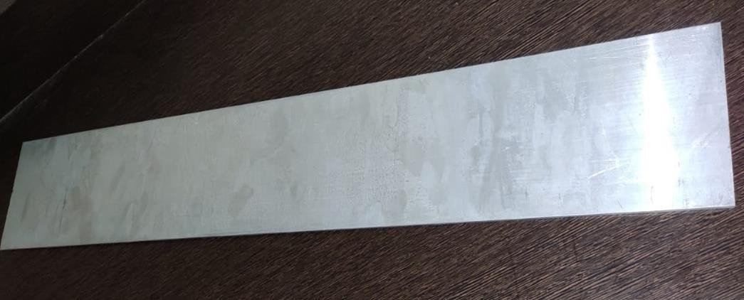

Fig.1: Base metal of 900*100 mm

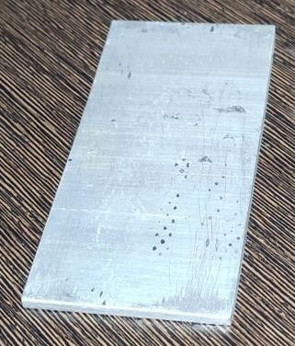

Fig.2: 100*50 mm specimen after cut

A FSW machine was used to butt-weld the welding samples, which were 200 mm by 100 mm. The tool rotational speed was kept constant at 1000 rpm, and the feed rate was measured in mm/min (30, 50, 70). The tool's shoulder diameter for FSW was 20 mm. After the FSW procedure, a tensile test was required to determine the weldment's tensile strength. In addition, in the laser cutting machine setup, the weldment was cut down according to the dimensions represented in figure.

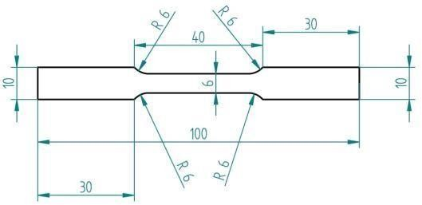

Fig.3: Tensile test specimen dimensions

Further, the friction-stir-welded zone was positioned in the sample's midsection. Using a KIPL-PC 2000 tensile testing machine, the test was carried out by gripping both ends of the samples at a regular speed of 3 mm/min.

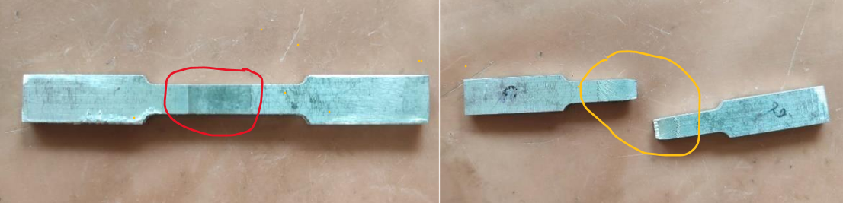

Fig.4: Before tensile test Fig.5: After tensile test

Further, in microhardness testing, a diamond indenter is used to make an indentation on the specimen while a load is applied to determine the hardness of the weld surface. This was accomplished using a Mitutoyo HM-200 micro hardness testing equipment. For microstructure evaluation, the samples were cross-sectioned perpendicular to the welding direction after the FSW. The weld specimens’ cross sections were polished with diamond paste and smoothed using a Metco semi-automatic polishing machine, then etched with Keller's etchant and viewed under optical microscope.

* 1. **Tensile test:** As the feed rate rises, the tensile strength rises with it. Lower feed rates result in less heat generation, which means less heat is provided to the base material, resulting in insufficient material flow and less plasticization in the stir zone, lowering tensile strength. The tensile test results are listed in the table below.

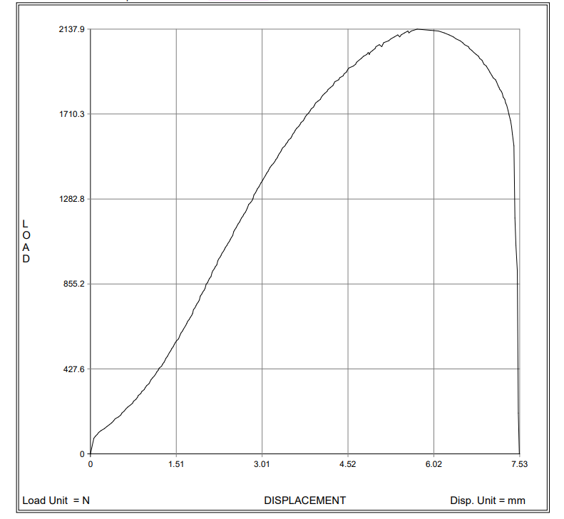

Fig.6: Load vs displacement graph (30mm/min)

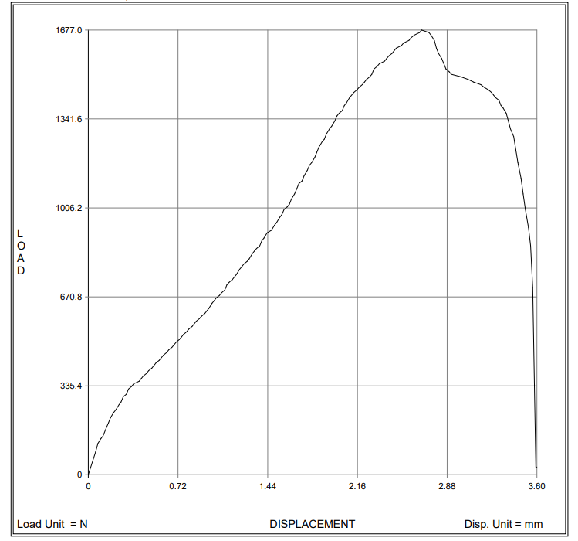

Fig.7: Load vs displacement graph (50mm/min)

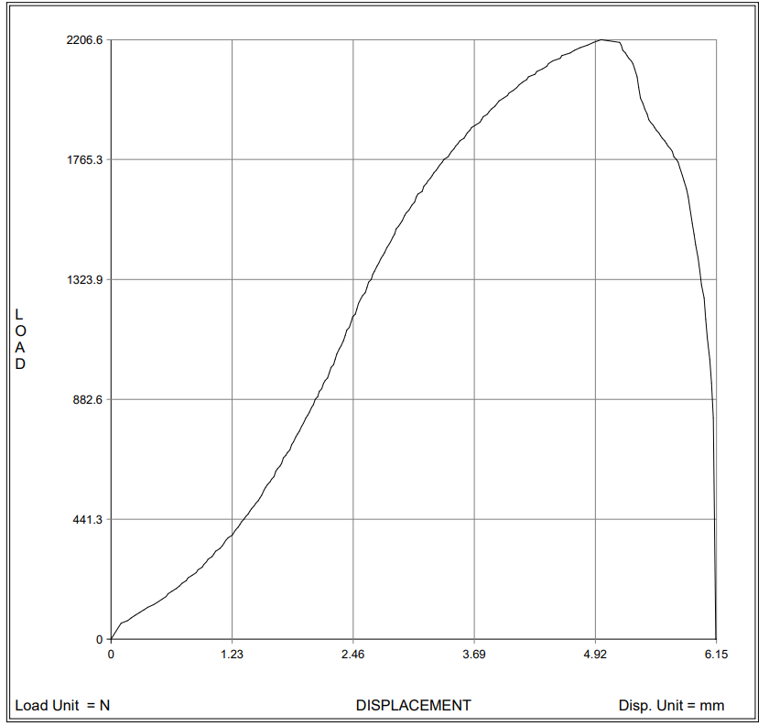

Fig.8: Load vs displacement graph (70mm/min)

Table 1: Tensile test results

|  |  |  |  |  |
| --- | --- | --- | --- | --- |
| RPM | Feed (mm/min) | Ultimate tensile load (N) | Break load (N) | Ultimate tensile strength (N/ sq. mm) |
| 1000 | 30 | 1981 | 1441 | 110.01 |
| 1000 | 50 | 1677 | 706.1 | 93.2 |
| 1000 | 70 | 2206 | 814 | 122.6 |

* 1. **Microstructure:** Each specimen's micro structure was obtained from the weld zone. The weld zone of the specimen was polished and then mirror imaged. After that, we employ Keller's reagent under an optimum microscope for etching. In the diagram below, the optical microstructures of the weld centre are illustrated. Due to the advanced temperature and extensive plastic deformation caused by the tool probe's stirring action, the grain arrangement within the nugget is well and stable, and the grain size is substantially smaller than that of the basic materials. The tool serves as a stirrer during FSW, extruding the material along the welding path. The cooling rate of the weldment was slowed by normal cooling, resulting in some irregular grains in some spots. The rate of cooling and temperature had a big impact on the re-crystallization. The fine grain size was achieved using a circular tool with a taper and welding values of 1000 rpm and 70 mm/min, respectively, for tool rotation speed and welding speed. Figures 8, 9 and 10 illustrate the microstructures of specimens.
  2. **Macro structure:** A number of more specific details involved in the semantic representation of discourse and action must wait until the respective chapters. The same holds for other aspects of meaning and knowledge representations that are necessary to account for discourse, and action and their macrostructures, such as frames or scripts, connection and coherence constraints, the format of macro rules, and the further analysis of action and interaction. Previously, actions were only analyzed in terms of a FACT schema, but many more aspects are involved that require our attention, such as their "underlying", mental plans, goals, purposes, motivations, or decisions. Similarly in this chapter, we have neglected to provide the more specific properties of pragmatics [accounting for the speech act(s) that, in a particular context, may be performed by using an utterance of a sentence or sentence sequence], although it is obvious that much of the semantics and the formation of FACTS depends on underlying pragmatic structures.

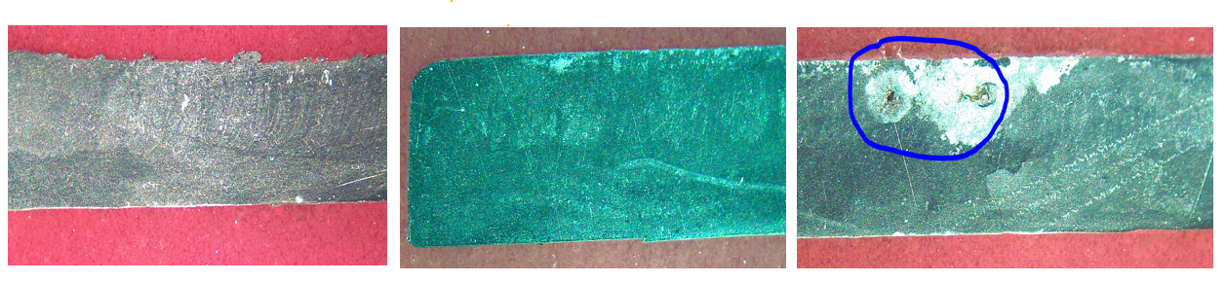

Fig.8: Macro test (30/ 50/ 70 mm/min)

## CONCLUSIONS AND SCOPE FOR FUTURE WORK:

FSW of similar welding is successfully conducted utilising a basic pin tool and a predetermined transverse and rotational speed.

* Smooth surface welding on the joints required enough heat input during the FSW process, which was proportional to the transverse and rotational speeds.
* The creation of onion rings and wavy distortion in the nugget zone for friction stir welding was caused by pin rotation during the stirring operation.
* Because of the movement of pins and materials on the advancing side, the microstructure was more abrupt than on the retreating side.
* The AA6061 welding efficiency is 92 percent. Future research should examine the weldability of junctions using different types of pins with the same welding settings.
* It is also advised that for future experiments, different speeds and feed rates be used to compare the weldment overview.
* Ultimate tensile strength for friction stir welding metal (AA6061) is 122.6 N/mm^2.

## ACKNOWLEDGEMENT:

This research was partially supported by NMAMIT Nitte, NITK Suratkal, MIT Manipal. We convey our sincere regards to above mentioned intitutes who assisted us in this project

## REFERENCES:

1. L. E. Murr, G. Liu, and J. C. Mcclure, “A TEM study of precipitation and related microstructures in friction-stir-welded 6061 aluminium,” *J. Mater. Sci.*, vol. 33, no. 5, pp. 1243–1251, 1998, doi: 10.1023/A:1004385928163.
2. W. Tang, X. Guo, J. C. McClure, L. E. Murr, and A. Nunes, “Heat input and temperature distribution in friction stir welding,” *J. Mater. Process. Manuf. Sci.*, vol. 7, no. 2, pp. 163–172, 1998, doi: 10.1106/55TF-PF2G-JBH2-1Q2B.
3. H. S. Park, T. Kimura, T. Murakami, Y. Nagano, K. Nakata, and M. Ushio, “Microstructures and mechanical properties of friction stir welds of 60% Cu-40% Zn copper alloy,” *Mater. Sci. Eng. A*, vol. 371, no. 1–2, pp. 160–169, 2004, doi: 10.1016/j.msea.2003.11.030.
4. Y. J. Kwon, I. Shigematsu, and N. Saito, “Dissimilar friction stir welding between magnesium and aluminum alloys,” *Mater. Lett.*, vol. 62, no. 23, pp. 3827–3829, 2008, doi: 10.1016/j.matlet.2008.04.080.
5. A. H. Feng, D. L. Chen, and Z. Y. Ma, “Microstructure and low-cycle fatigue of a friction- stirwelded 6061 aluminum alloy,” *Metall. Mater. Trans. A Phys. Metall. Mater. Sci.*, vol. 41, no. 10, pp. 2626–2641, 2010, doi: 10.1007/s11661-010-0279-2.
6. P. J. Ramulu, R. G. Narayanan, S. V. Kailas, and J. Reddy, “Internal defect and process parameter analysis during friction stir welding of Al 6061 sheets,” *Int. J. Adv. Manuf. Technol.*, vol. 65, no. 9–12, pp. 1515–1528, 2013, doi: 10.1007/s00170-012-4276-z.
7. M. Indira Rani, R. N. Marpu, and A. C. S. Kumar, “A study of process parameters of friction stir welded AA 6061 aluminum alloy in O and T6 conditions,” *ARPN J. Eng. Appl. Sci.*, vol. 6, no. 2, pp. 61–66, 2011.
8. D. Li, X. Yang, L. Cui, F. He, and H. Shen, “Effect of welding parameters on microstructure and mechanical properties of AA6061-T6 butt welded joints by stationary shoulder friction stir welding,” *Mater. Des.*, vol. 64, pp. 251–260, 2014, doi: 10.1016/j.matdes.2014.07.046.
9. M. A. Abdulstaar, K. J. Al-Fadhalah, and L. Wagner, “Microstructural variation through weld thickness and mechanical properties of peened friction stir welded 6061 aluminum alloy joints,” *Mater. Charact.*, vol. 126, pp. 64–73, 2017, doi: 10.1016/j.matchar.2017.02.011.
10. D. Venkateswarulu, M. Cheepu, D. Krishnaja, and S. Muthukumaran, “Influence of Water Cooling and Post-Weld Ageing on Mechanical and Microstructural Properties of the FrictionStir Welded 6061 Aluminium Alloy Joints,” *Appl. Mech. Mater.*, vol. 877, no. February, pp. 163– 176, 2018, doi: 10.4028/[www.scientific.net/amm.877.163.](http://www.scientific.net/amm.877.163)
11. A. Kalinenko *et al.*, “Microstructure-strength relationship in friction-stir welded 6061-T6 aluminum alloy,” *Mater. Sci. Eng. A*, vol. 793, p. 139858, 2020, doi: 10.1016/j.msea.2020.139858.